President | Shaun Manthey  Kingaroy SFC  P: 0419789129  E: Qldsportfisherspresident@gmail.com  FB: www.facebook.com/100010071978438 | 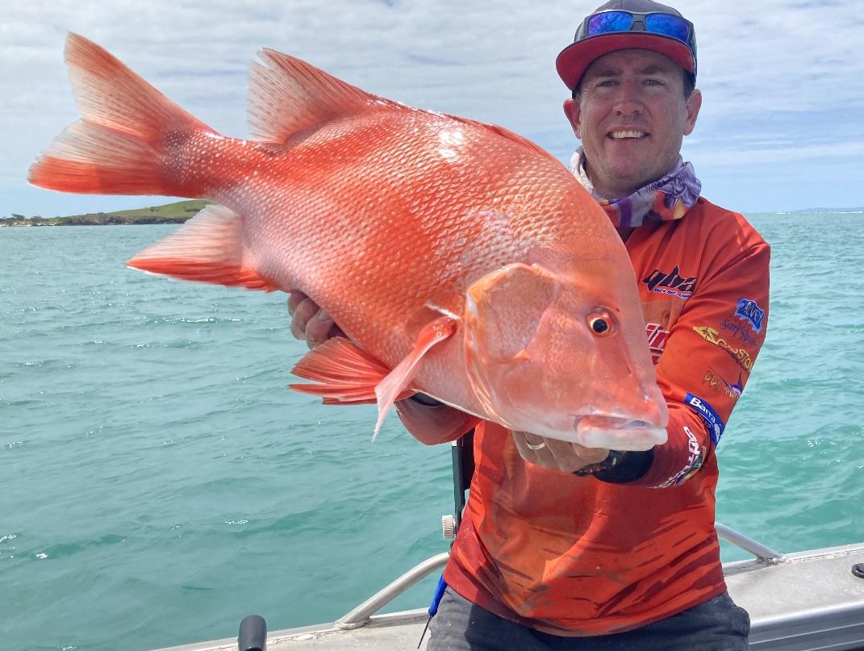
Vice President | Adam Royle  Hinchinbrook SFC  P: 0417610446  E: nqfisho@live.com.au  FB: www.facebook.com/adam.royle.100 | 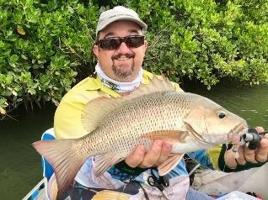
Secretary | Rod Enkelmann  Keppel Bay SFC  P: 0421927670  E: rodenkelmann@gmail.com  FB: www.facebook.com/rodney.enkelmann | 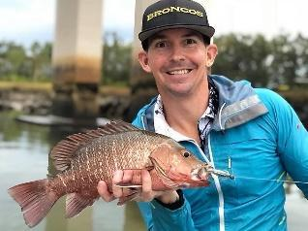
Treasurer | Andrew Doherty  Redcliffe Peninsula G&SFC  P: 0422267839  E: andrew.d@hotmail.com.au  FB: www.facebook.com/andrew.doherty.946179 | 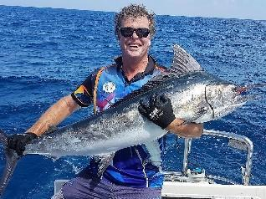
Media & Promotions Officer | Ashley Schiffke  Bundaberg SFC  P: 0448070837  E: atschiffke-1989@hotmail.com  FB: www.facebook.com/ashley.schiffke | 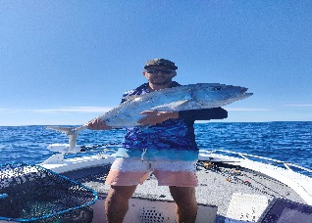
Events Coordinator  (Convenor) | Mick King  Redcliffe Peninsula G&SFC  P: 0409750677  E: kingsfour@bigpond.com  FB: www.facebook.com/michael.king.18 | 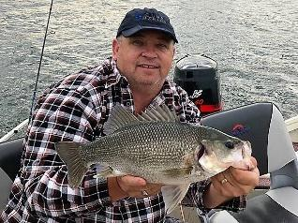
Records Officer | Helen Johnson  Hinchinbrook SFC  P: 0408055531  E: helter5@hotmail.com.au  FB: www.facebook.com/helen.johnson.7545 | 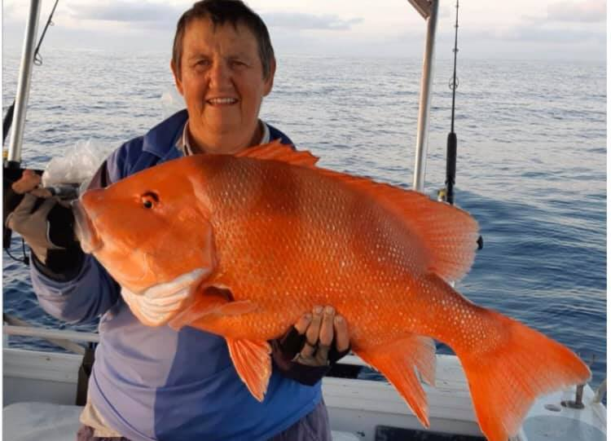
Research & Tagging Officer | Chris Proctor  Ipswich United SFC  P: 0491130279  E: proctorchris474@gmail.com  FB: www.facebook.com/100080817166335 | 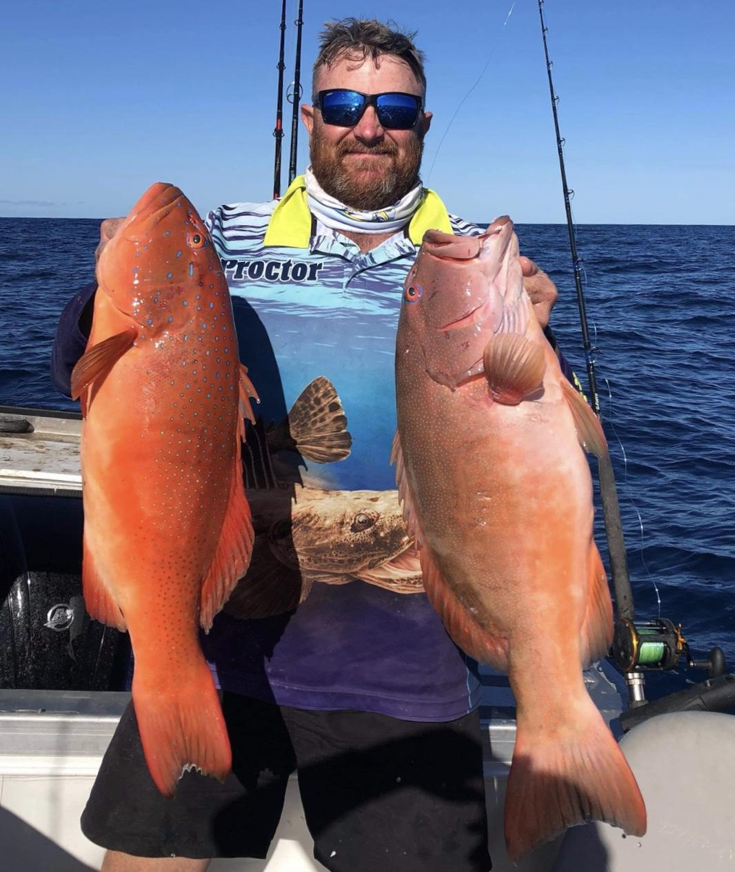
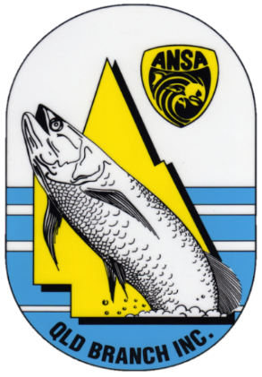

AUSTRALIAN NATIONAL SPORTFISHING ASSOCIATION QUEENSLAND
Qld Sportsfishers Contacts
(2022/23)

